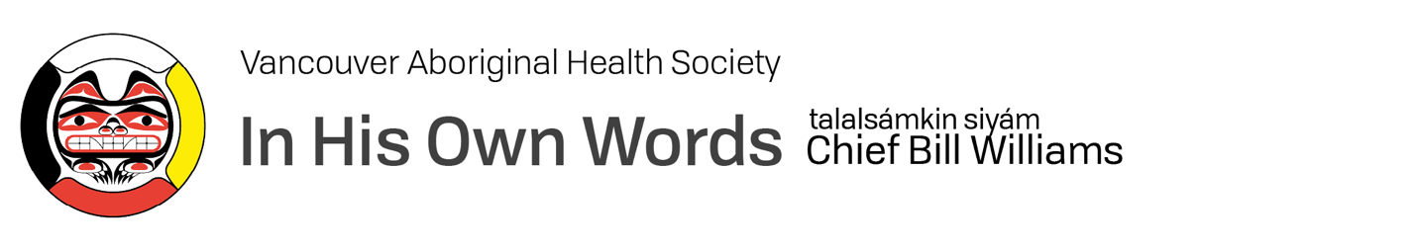

Tell us a little something about yourself…

My name is Chief Bill Williams, talalsámkin siyám, and I am a Hereditary Chief of Sk̲wx̲wú7mesh Nation and a member of the Vancouver Aboriginal Health Society’s team. I was born in a place called Nanaimo and was raised by my grandmother since the age of five. My grandmother was born in 1875 and lived until she was 98. She was a wealth of information about what is known as the “old language” and shared her knowledge widely. I had the good fortunate to have lived with her for 18 years.

As I was going through high school, I was always told that I was a leader, and it was my responsibility to lead the young people in the community. At the age of 15, I was given a copy of the Indian Act to read. I was deeply hurt by what I saw and started asking questions. I went to our school board and told them, “We have a huge problem.” I had talked to my white friends, the Berkowskis, who had 10 kids. My cousins, the Lewis family, also had 10 kids. The contribution that each of those families were given to the school board for our education was concerning. The Berkowski family was contributing $410 per year to educate their whole family. On the other hand, the federal government was contributing $6500 for each Native student going to our school. With all that money, we weren’t given any support or resources at all to be successful. I also asked why the school board streamlined every Native who came to our school to occupational skills. They kicked us out at Grade 10 without a graduation certificate and no offer of academics. I told them that day that I wanted an academic education starting immediately and to have the opportunity to celebrate my graduation—like everybody else.

I went on to graduate from Langara College with a degree in Recreational Leadership, followed by a degree at BCIT in Business Administration and Marketing. I guess you can say that I learned early on the importance and value of advocating for what you believe in.

In addition to being a Hereditary Chief, you also served as Band Manager for the Squamish First Nations Council, and as an elected member of the council for thirty years. What did you find was the greatest reward?

Helping our people, the children, and the land. There was a time when we as a council helped to develop the “Sacred Land”. We spent four years within the community talking about the land outside the reserve system and we created our own Squamish land use plan. We gave it to the Province of British Columbia. It took them three years to figure out what it was all about and whether we were doing what we should be doing. I hired consultants who had worked with the province and knew everything that would help us.

The province accepted the land use plan in 2007. We set aside 8,200 hectares of land. Ten thousand were set aside for everyone to access, another 20,000 for people who could only hike into those remote areas, and 10,000 hectares for Squamish Nation members to take their children and youth to learn about the land. Lastly, 20,000 hectares were set aside to be left alone for no one to enter. To remain untouched. This was the first land use plan that any government in Canada had ever accepted.

Tell us about your work with VAHS.

I first connected with VAHS through a friend that I worked with as Chiefs. Working with VAHS has been wonderful. There are fabulous people here. The work that we do here brings people from the street into this place where they feel safe and comfortable and understood. It’s a special place. There are many people here from all different nations. As well, there are many people who have grown up in the Downtown Eastside and don’t know about the Coast Salish ways and teachings. About doing things the correct way. I am blessed to have had the teachings from my grandmother and along with the other Knowledge Keepers who work here, it is important that we share our knowledge with others.

What do you think about the new VAHS Healing Centre?

The importance of this project is huge. We as Indigenous People have been forced by the Indian Act to only get services from the Federal Government of Canada. The Government of Canada has always said to us that as soon as you move off of the reserve, they will no longer fund us. This has been a major problem for Indigenous people who are forced off reserve. With the program being developed, it is getting close to what looks like an Indigenous community. As an Indigenous community we have Elders, schools, places where teachings are shared. What this new building will be is a mini-Indigenous community, similar to what is offered on a reserve. Access will be easy and all the good things you need for a safe environment will be under one structure.

Indigenous people are like everyone else. We need a safe home, a safe environment, we need to be able to access services that everyone else can access. We need to build this service so that people can learn the teachings.

What motivates you to do what you do?

Giving out the teachings—snew̓íyelh—who we are and where we came from. I saw my grandmother do that all her life. Most of my life I was tied up with the business end, so now it’s time to give out the teachings that were given to me. I don’t own them. They belong to the community. To the children.

Beyond the work that you do at VAHS, how do you enjoy spending your time?

I enjoy going out on the land. Each and every morning I go out on the land where I do my prayers and connect with the land. Right now, I spend early mornings in Lynn Creek.

For 10 years, I invited people to join me camping and learn a traditional cultural camp. Over the course of that time, I led over 15,000 interested people over a weekend to Sims Creek to experience this cultural experience. In the near future I hope to do this again. Children learning the culture and connecting people who have been lost. It is incredibly powerful.

For More Information

For more information, or to arrange an interview with Chief Bill Williams, please contact:

Sonya Hwang
Ki Communications
T: 604-902-1977
E: sonya@kicommunications.ca

