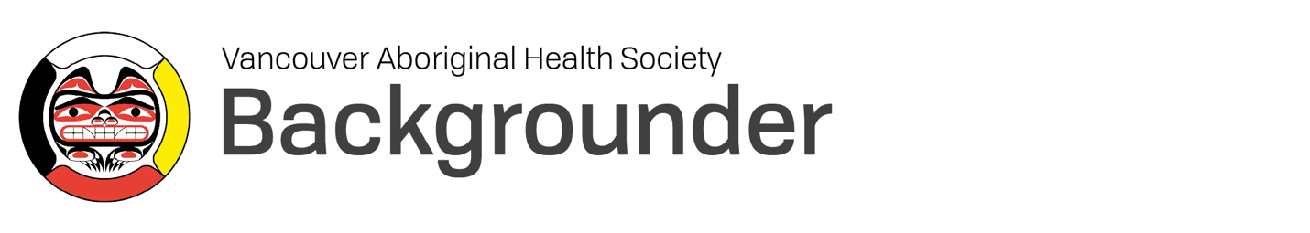

Introducing VAHS

Since 1991, Vancouver Aboriginal Health Society (VAHS) has delivered culturally grounded services—by and for urban Indigenous people—to promote physical, mental, emotional, and spiritual wellness. VAHS has grown from an after-hours clinic to a leader in full-scope medical, dental, cultural, and social services for urban Indigenous individuals and families.

VAHS employs a Circle of Care model that is rooted in more than 30 years of services and thousands of years of ancestral knowledge. This model reclaims Indigenous healing practices in urban spaces by offering low-barrier access to both Indigenous and Western approaches to care. With a focus on empowerment and self-determination, we create pathways to healing that are trauma-informed, relevant, and unique to each person.

VAHS History

VAHS was formed in the early 1990s as an after-hours medical clinic, in response to the lack of culturally safe and appropriate health care for urban Indigenous people living in the Downtown Eastside. The philosophy of VAHS was founded on an Indigenous understanding of the deep connections between individual and community wellness: Good health in one, is essential to good health in the other.

VAHS services grew to meet the changing health needs in its communities, including the increasing prevalence, stigma, and impacts of HIV in the mid-1990s. As one of the first urban Indigenous health organizations in Canada, VAHS became a leader in using both knowledge and Western medicine to address health challenges rooted in poverty, colonialism, and intergenerational trauma.

Alongside its Primary Care Clinic, VAHS has delivered Indigenous Early Years family programs for over 20 years and a Dental Clinic with by-donation services since 2008. VAHS’s circle of Elders and Knowledge Keepers offers emotional and spiritual supports through counselling, traditional medicines, workshops, ceremonies, and land-based healing opportunities.

Today, VAHS’s team of nearly 100 employees supports more than 4,000 people each year on their healing journeys—and this is only the beginning.

VAHS’s Vision and Mission

Vision: A connected and empowered urban Aboriginal community that enjoys physical, mental, emotional, and spiritual wellness.

Mission: To provide holistic wellness services and programs rooted in respect, safety, and Aboriginal cultures and knowledges.

Where VAHS is Going

Rooted in tradition, ceremony and ancestral knowledge, land-based healing creates community, fosters a sense of belonging, and connects us to something bigger. It’s also what makes VAHS different.

From Pipe Ceremonies held on the back porch of the clinic, to sweat lodges in the East Hastings community garden, and daily cultural workshops on-site, VAHS is committed to revitalizing land-based healing in urban spaces. These critical health offerings are about to expand, thanks to the Housing and Healing Centre project at 52-92 East Hastings Street a collaboration of the Aboriginal Land Trust, VAHS, Lu’ma Native Housing Society, and RainCity Housing. Opening in Fall 2023, the VAHS Healing Centre will provide ongoing land-based healing opportunities as well as culturally safe primary care, dental care, counselling, and social supports to urban Indigenous people in
Vancouver. The new facility will bring these programs under one roof for the first time, allowing for greater collaboration and further integration of land-based healing into VAHS’s services.

The new VAHS Healing Centre’s ceremonial and garden spaces will provide opportunities to connect people to the rich histories of these lands, as stewarded by the xʷməθkwəy̓əm (Musqueam), Sḵwx̱wú7mesh (Squamish), and səl̓ilwətaɁɬ (Tsleil‑Waututh) Nations since immemorial.

Supporting VAHS Healing Centre

VAHS is engaged in ongoing fundraising to meet the new Healing Centre’s $20 million budget. To learn how both private and corporate donors can support this innovative project, please visit the website at vahs.life.

From VAHS Leaders

“I’ve seen the impacts of land-based healing on Indigenous health and they have been tremendously positive. Connecting to our ancestors’ ways through the teachings of our Knowledge Keepers and Elders is powerful medicine that alleviates the pain caused by the profound intergenerational trauma that is the legacy of colonialism.”
— Rosemary Stager-Wallace
Executive Director

“The new VAHS Healing Centre will be a place of traditional knowledge that is put into practice alongside of Western medicine. It will be place of true, Indigenous, holistic healing.”
— Chief Bill Williams
Elders and Cultural Program

For More Information

For more information, or to arrange an interview with Executive Director Rosemary Stager-Wallace, Chief Bill Williams, or Policy Analyst/Director of Innovation Marlee Poole, please contact:

Sonya Hwang
Ki Communications
T: 604-902-1977
E: sonya@kicommunications.ca

